**Admin Panel**

***Updated 17.06.2015***

1. Click on link = /support/manual

Preview smartphone screen encounters error

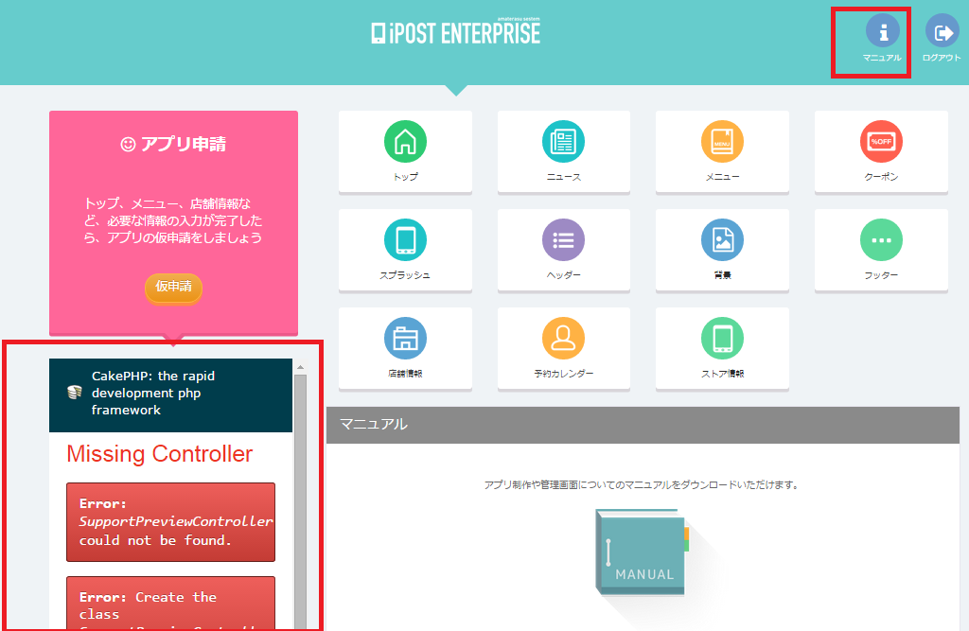

1. Click on icons, then click into “Click here” text as hightlighted in red below => encounter error

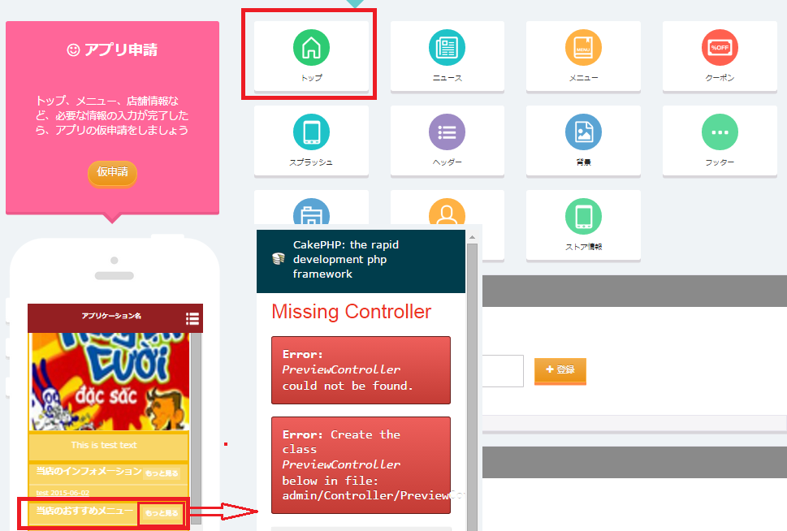

1. News & other forms

* style textbox # selectbox error

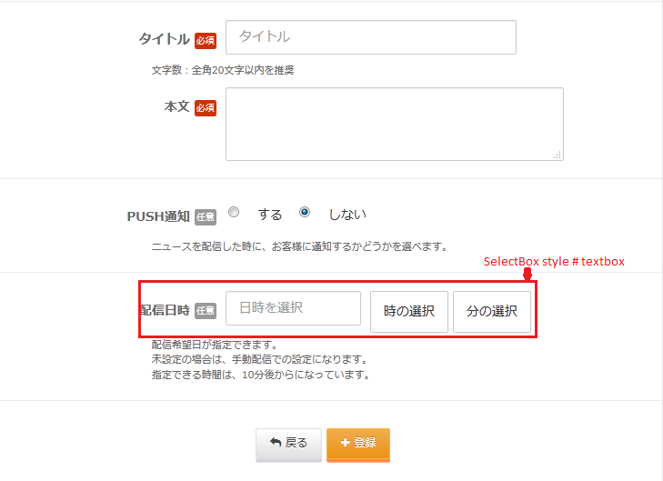

1. Menu

* Advane or button Back

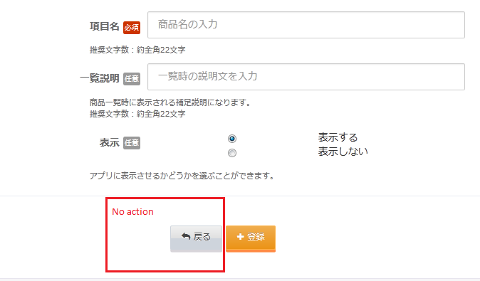

1. Splash

* Setting splash image

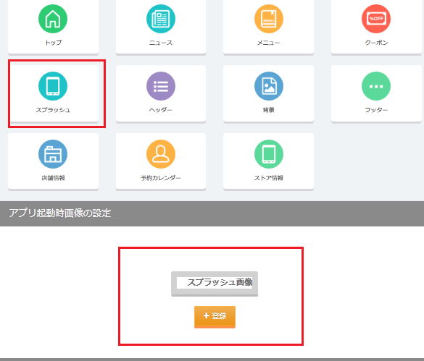

1. Background

* Can not set background image

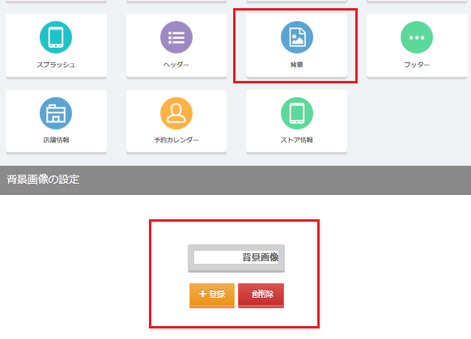

1. Footer

* When insert then currently API /**tabmenu/[CLIENT_ID]** result = [{"type":"top","icon":"0"},{"type":"top","icon":"1"},{"type":"news","icon":"3"},{"type":"news","icon":"16"},{"type":"news","icon":"14"}]

But must correct as below = [{"type":"top","icon":"A"},{"type":"top","icon":"C"},{"type":"news","icon":"D"},{"type":"news","icon":"E"},{"type":"news","icon":"F"}]

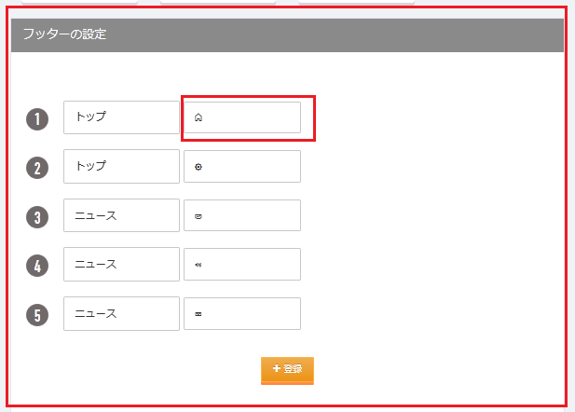

1. Shop profile

* Edit shop image errors

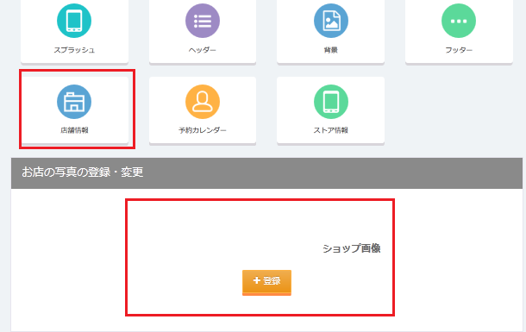

1. SideMenu

* Disappear side menu management in admin panel?

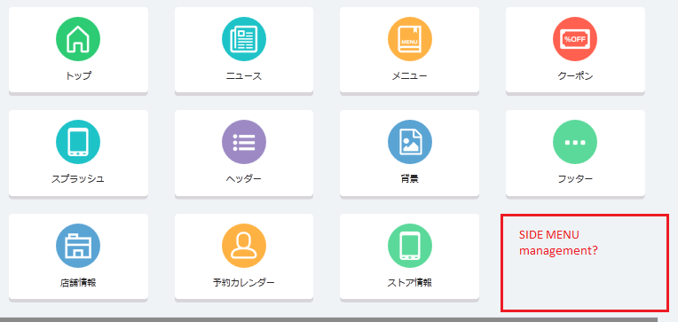

1. News
2. Create news – Do not validate this form?

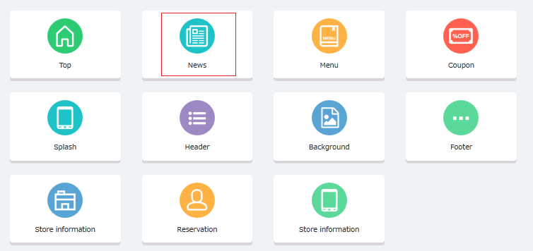

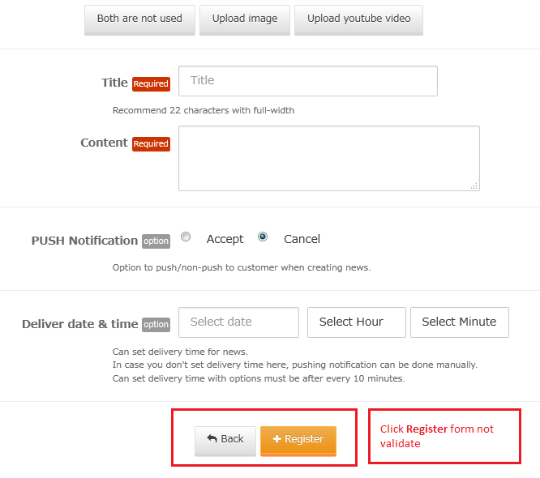

1. Edit News – Image disappears after edit?

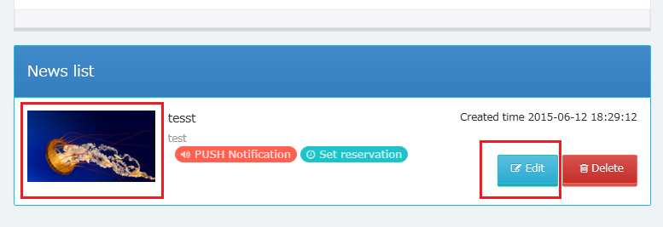

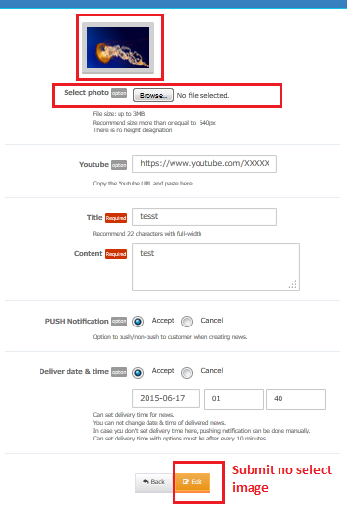

1. Menu

* Add Item do not validate any form?

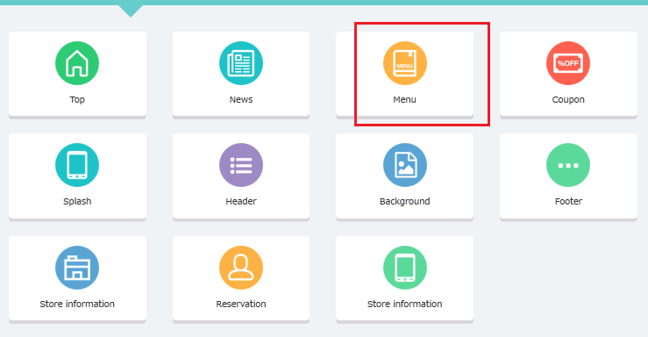

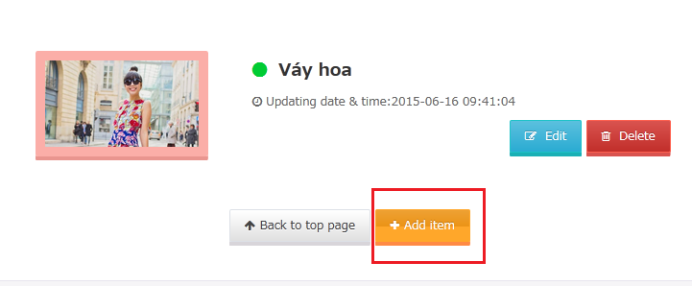

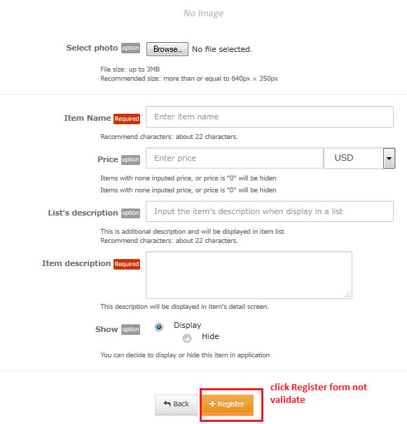

1. Block

* Click Register => No action?

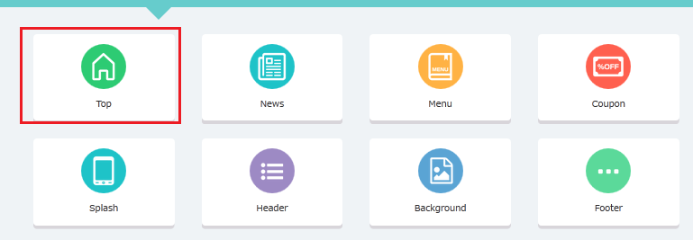

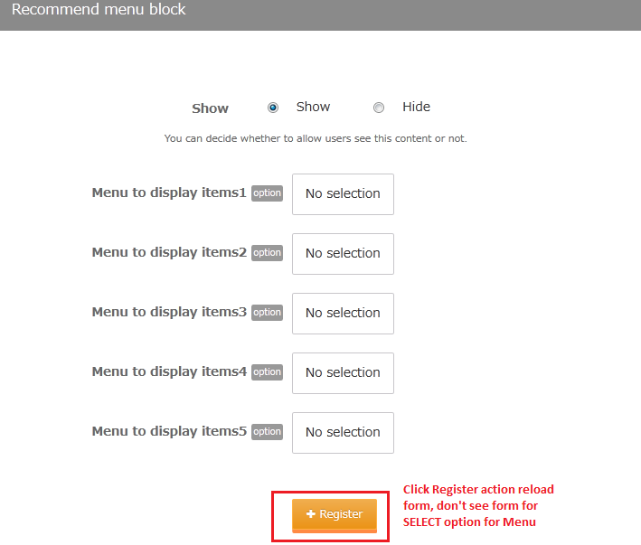

1. TOP

* Different with old Version: do not allow to configure in Admin panel?

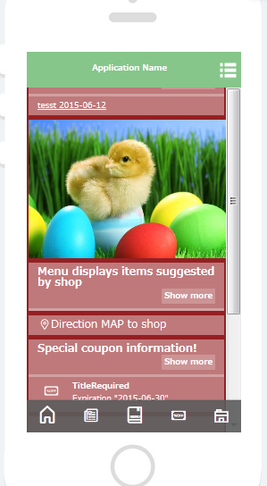

**API**

1. API TOP : /top/[client_id]

* API TOP is different with old version?

1. API TABEMENU: /tabmenu/[client_id]

* Missing sidemenu management in Admin panel => Could not test this API